Welcome to iBudget!

We’re happy to have you using our website! Here we’ve got an intro to quickly get you up to speed and managing your finances better than ever.

This document will take you through creating an account, navigating the website, and using all the tools we’ve provided here for you.

Let’s take a look at the home page (<ibudget.simplefunctions.com>) :

**Navigation Bar**

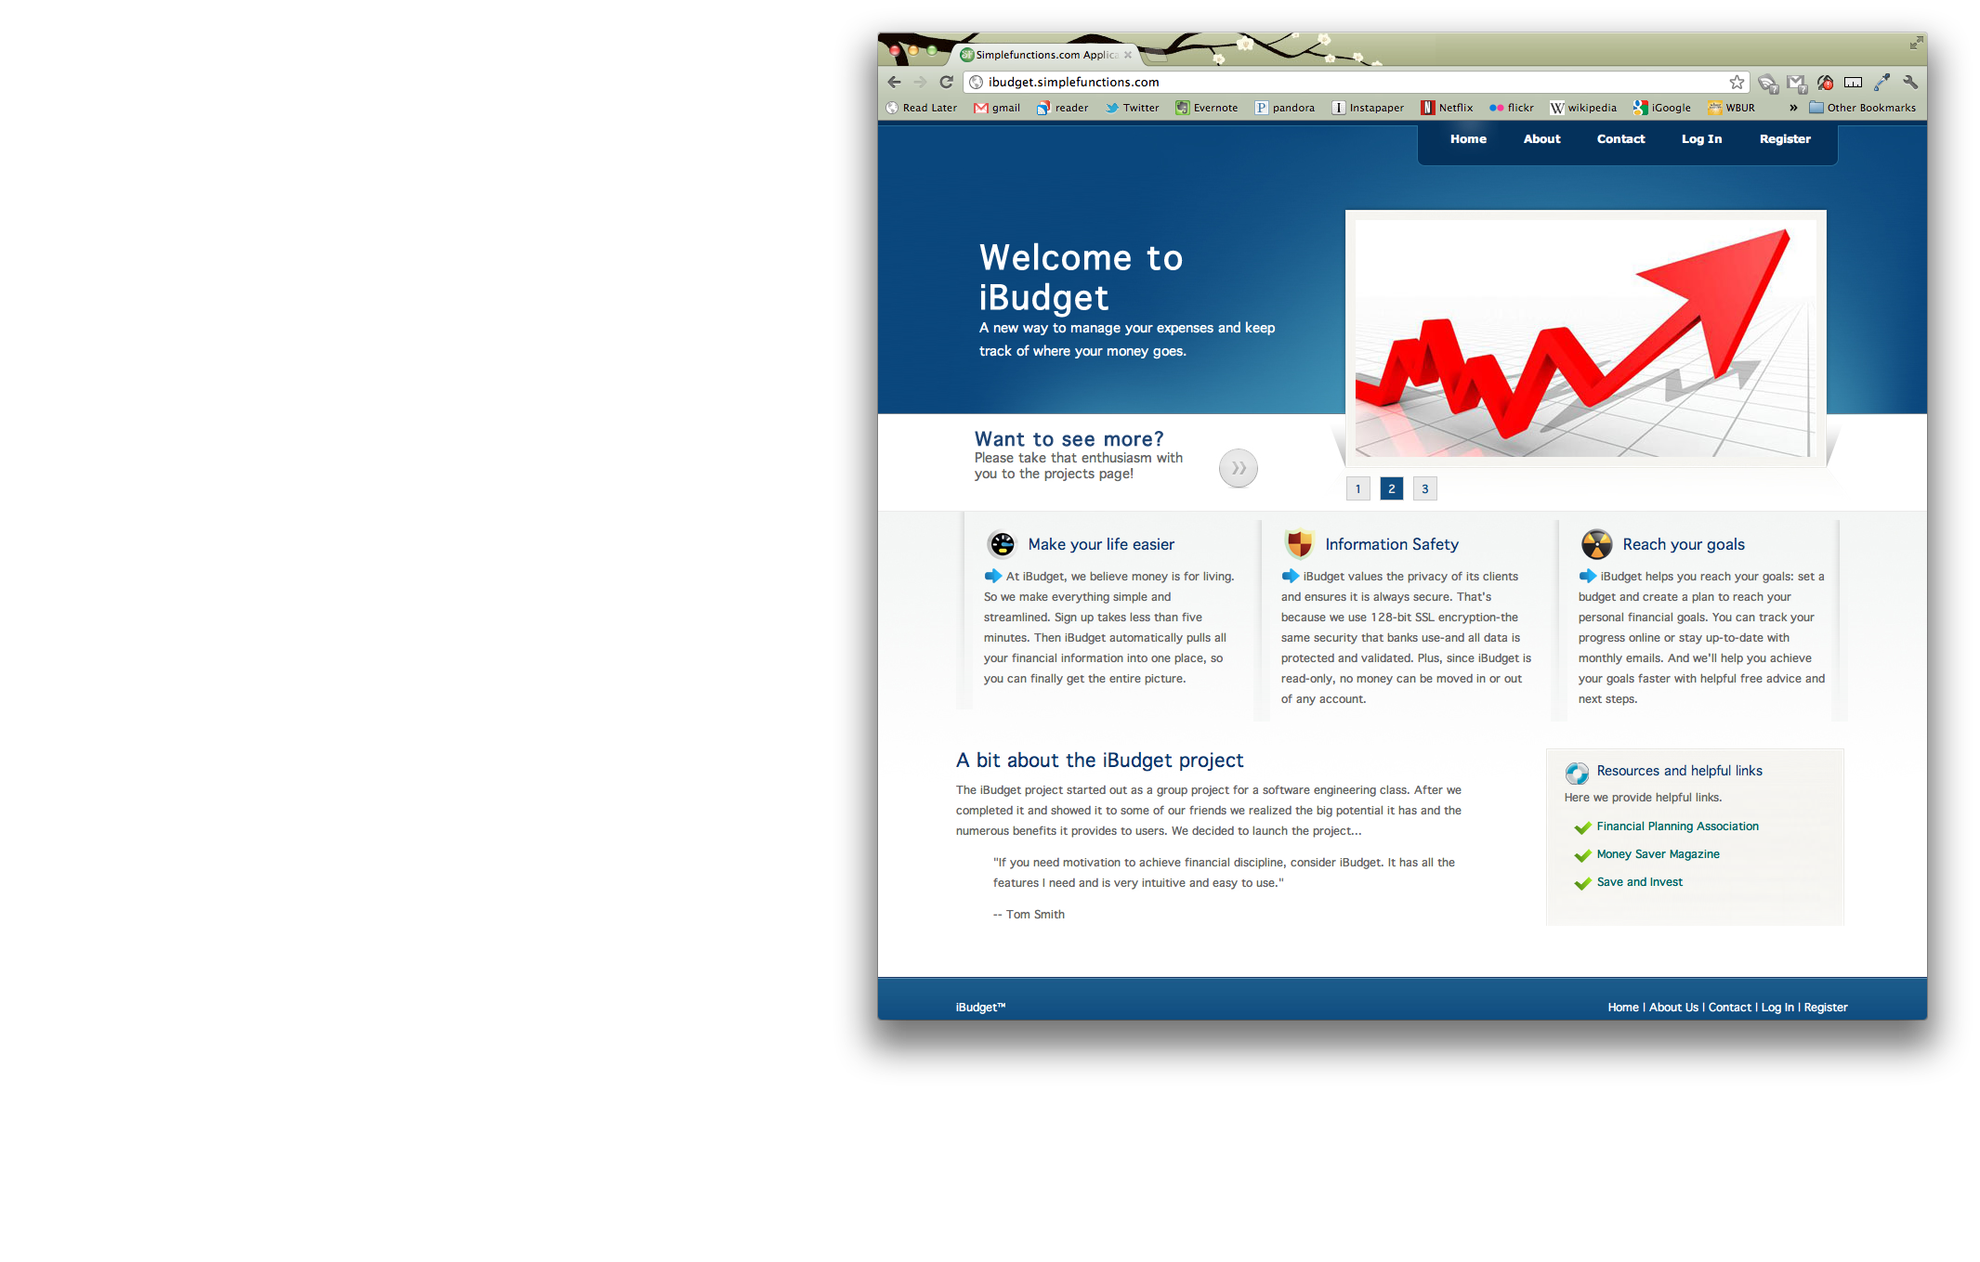

**Useful Links**

**Creating an Account**

First click on the **Register** link in the *Navigation Bar*. Then fill out your email and a password, make sure your password is at least 8 characters, has an upper case, lower case, numeric, and special character.

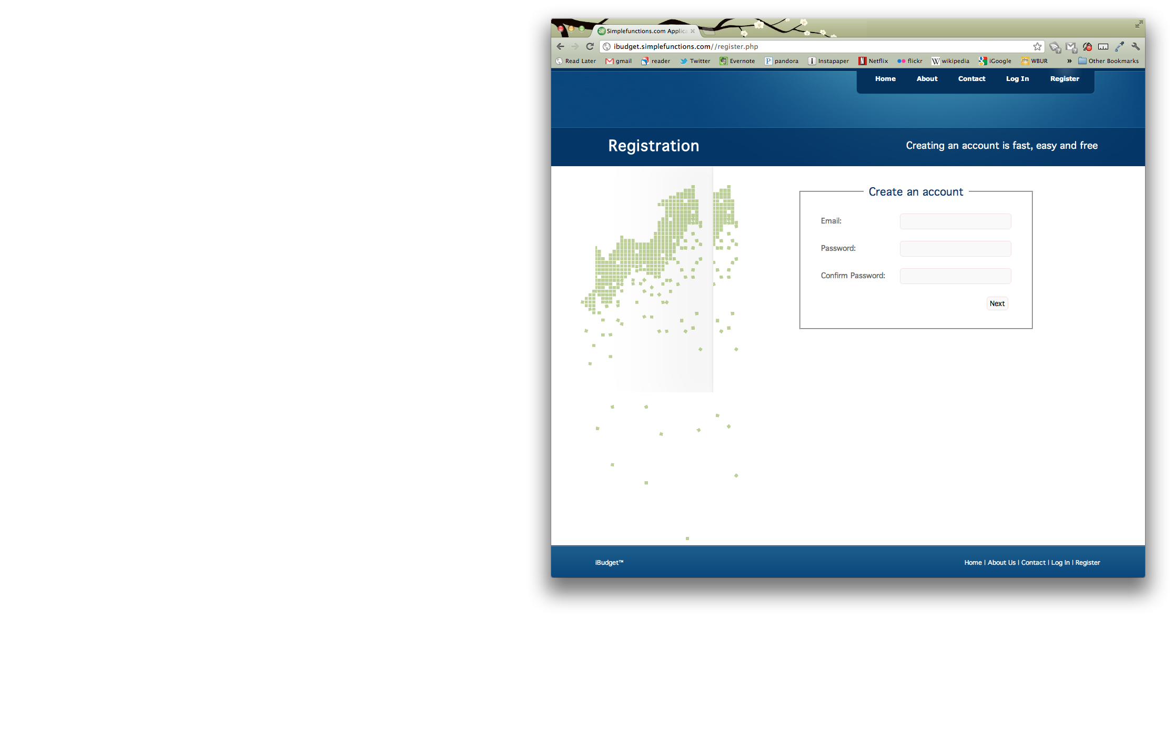

Click “Next” and then fill out your first and last name:

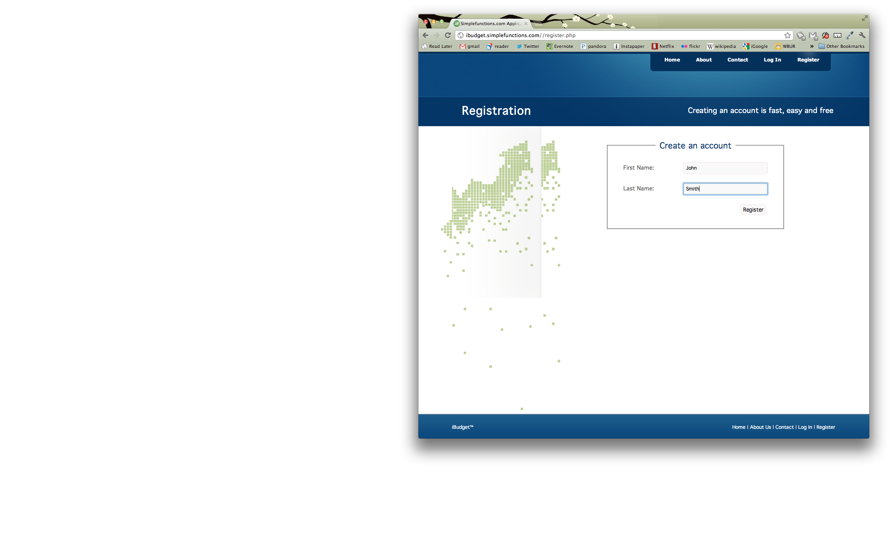

Click “Register” and then your done! You’re now registered to use iBudget.

**Log In to your Account**

Click on the **Log In** link in the *Navigation Bar*. Then fill in your registered email and your password.

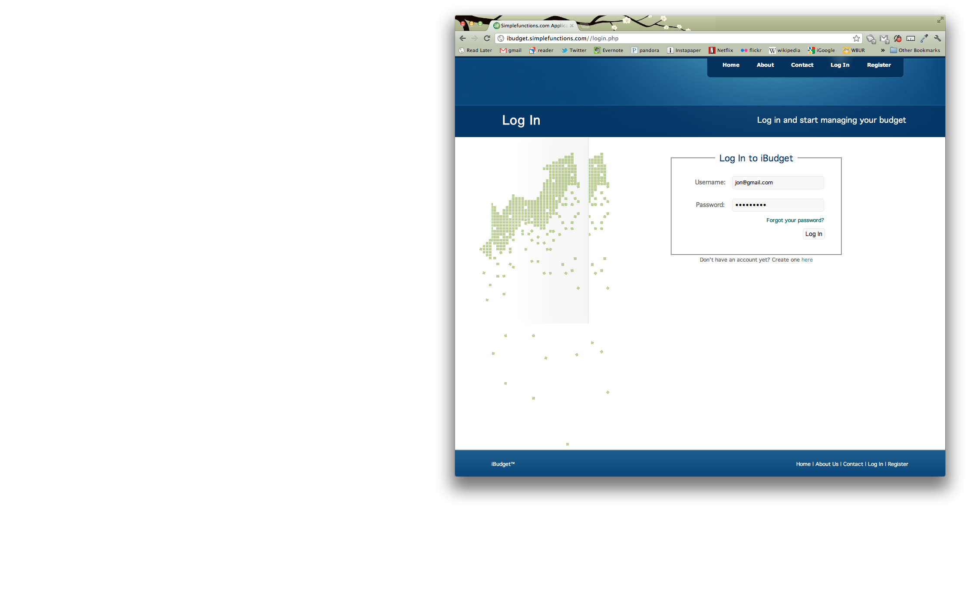

Click the “Log In” button and you’re done.

**Dashboard**

To access the dashboard, you’ll have to log in to your account first. Then click on the **Dashboard** link in the *Navigation Bar*.

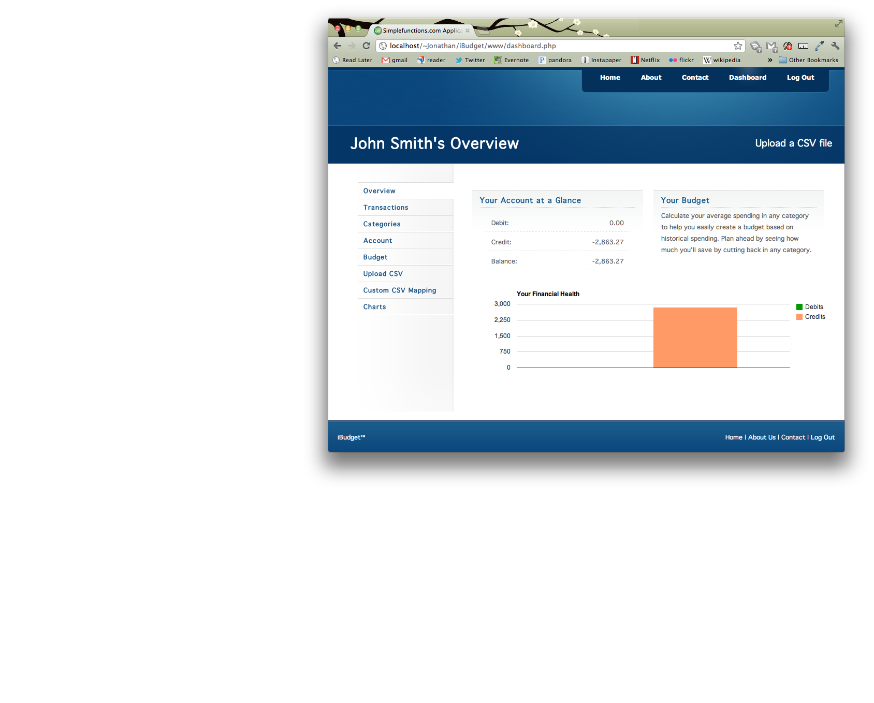

**Dashboard Navigation Pane**

**Categories**

You can use categories to group your transactions and assign budgets. To manage your categories click on the **Categories** link in the *Dashboard Navigation Pane*.

To add a new category, click the “Add New Category” button.

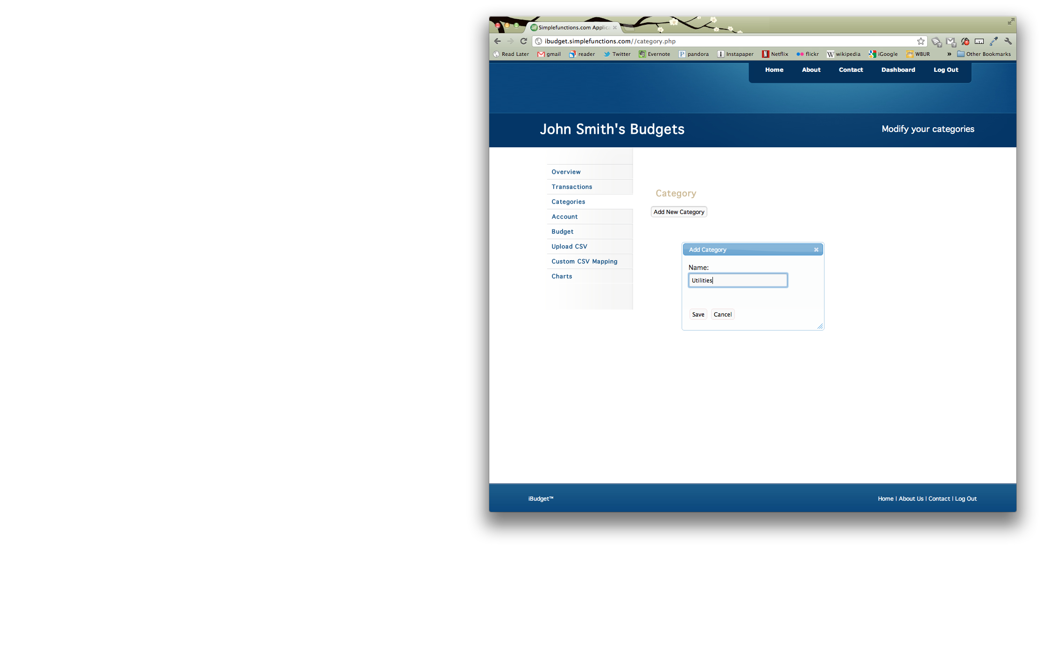

Select a category, enter a name and then click the “Save” button.

To delete a category, click the “Remove” button next to the category item you want to remove.

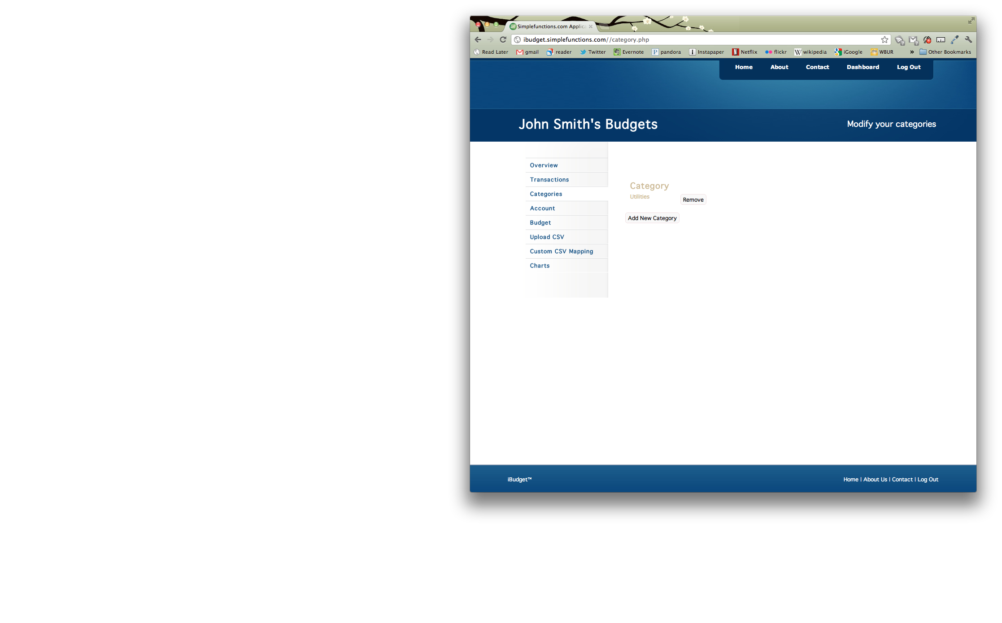

**Add Transactions**

You can upload CSV files from any account, in fact we already have a few predefined mappings for you (we’ll show you how to create more mappings next, if you need).

To upload transactions, click on **Upload CSV** in the *Dashboard Navigation Pane*.

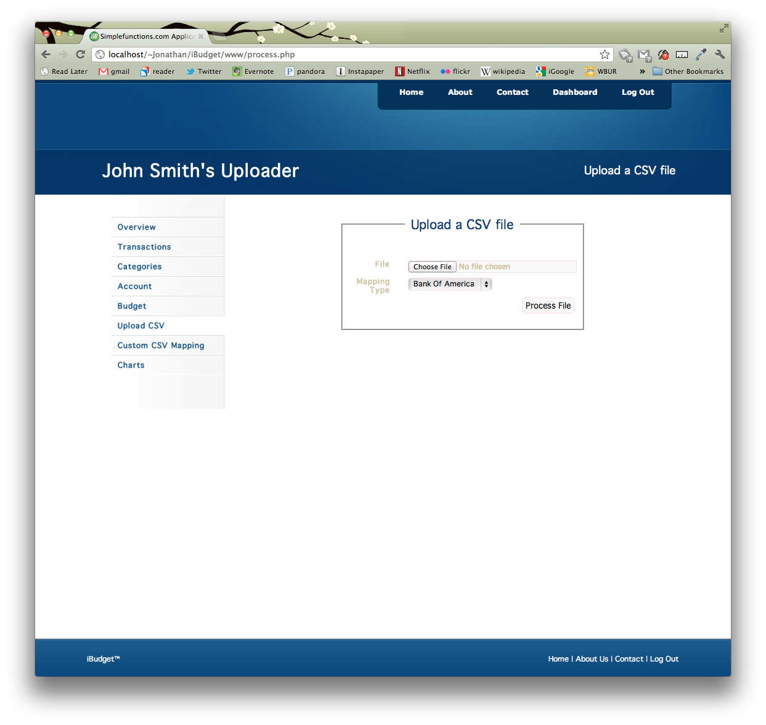

Choose the file you want to upload, select the proper mapping and click the “Process File” button. If everything goes properly, you should see the screen below.

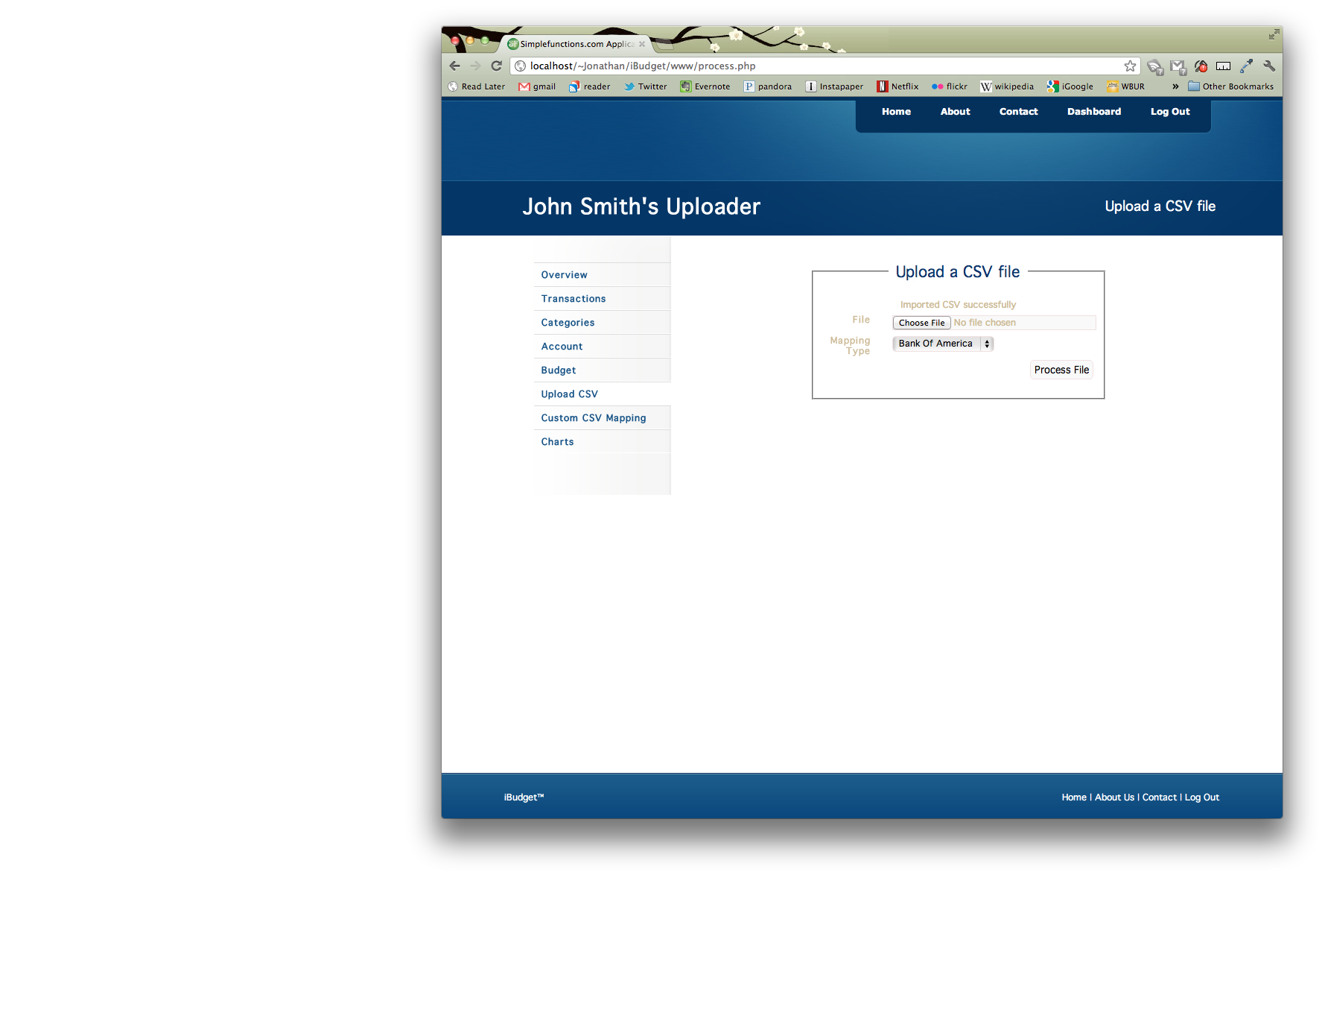

**Create a custom mapping for your CSV file**

To create a custom mapping as discussed in the Add Transactions section, click on the **Custom CSV Mapping** link in the *Dashboard Navigation Pane*.

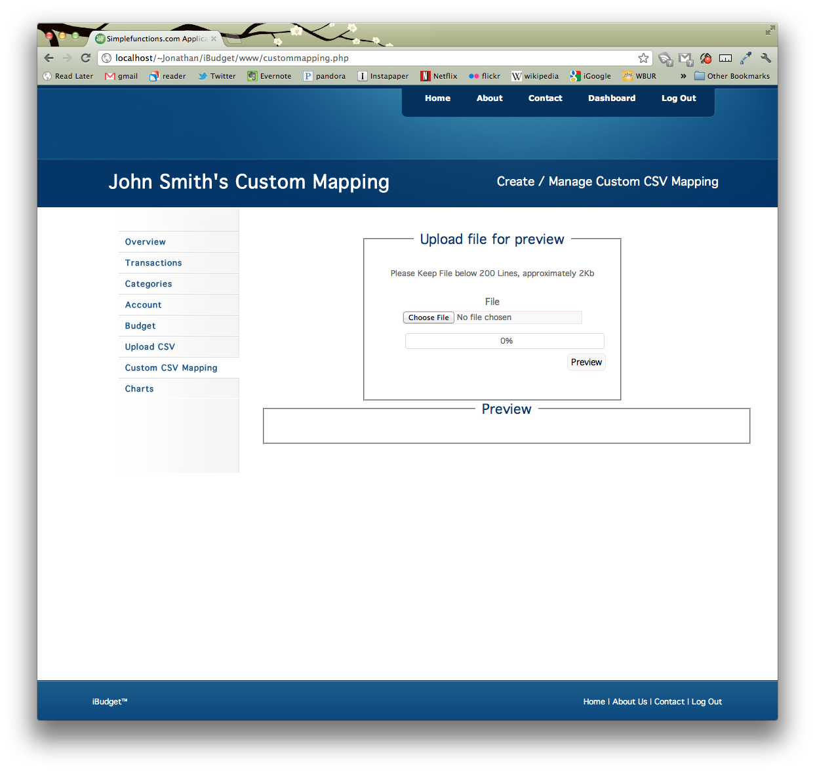

Choose a file then click the “Preview” button. You should now see a preview of the file you want to create a mapping for, like below.

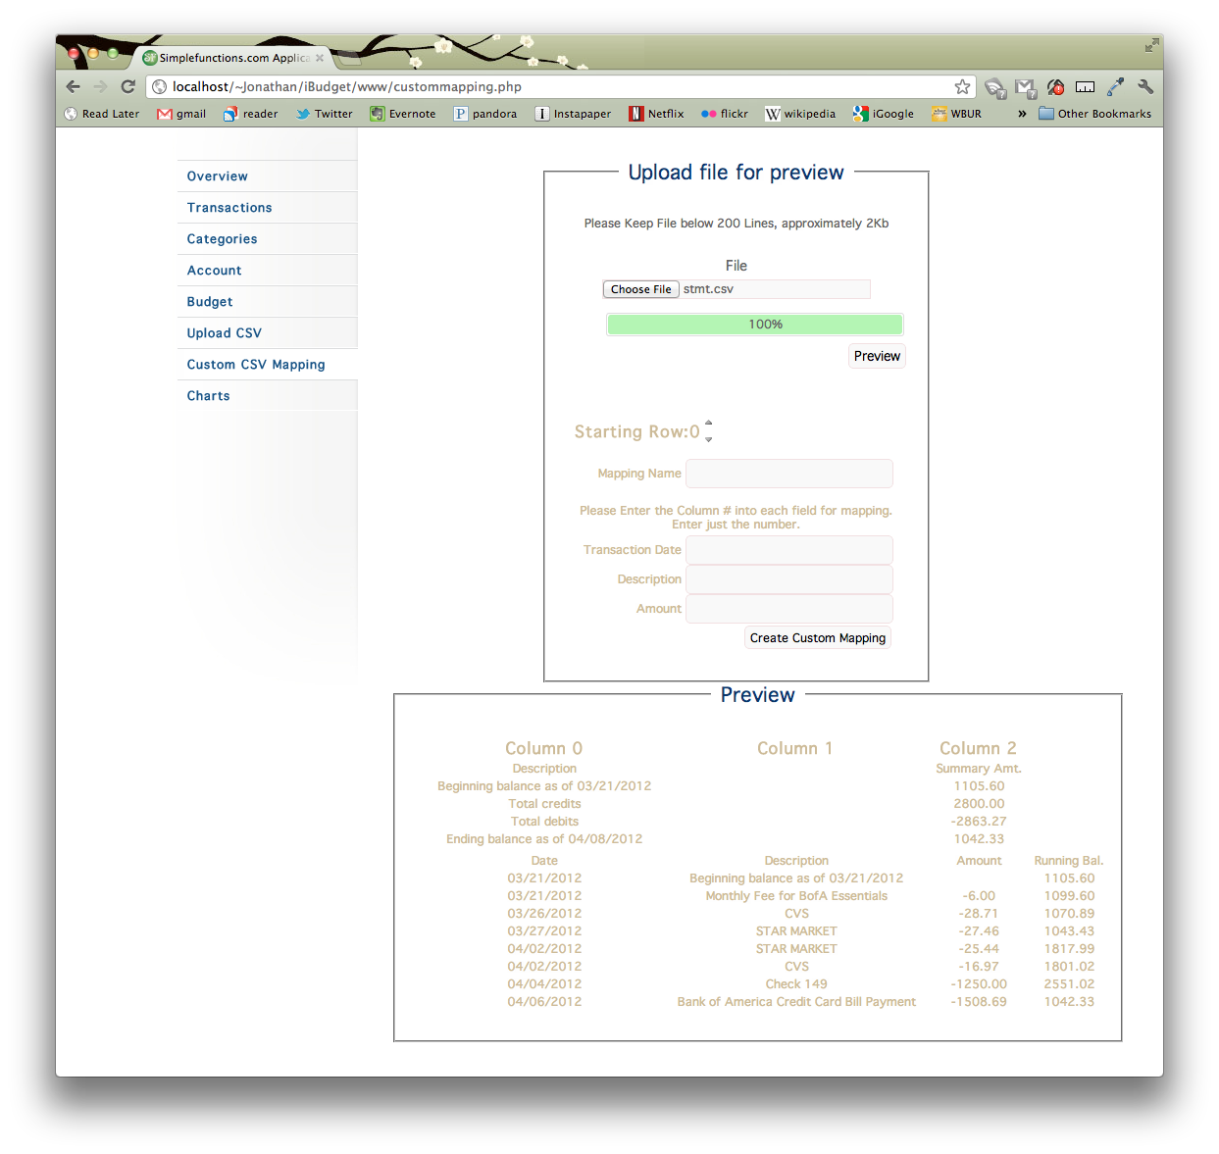

Clearly the first few lines of the file should not be uploaded, as you adjust the “Starting Row” as highlighted below, you’ll see the preview adjust appropriately.

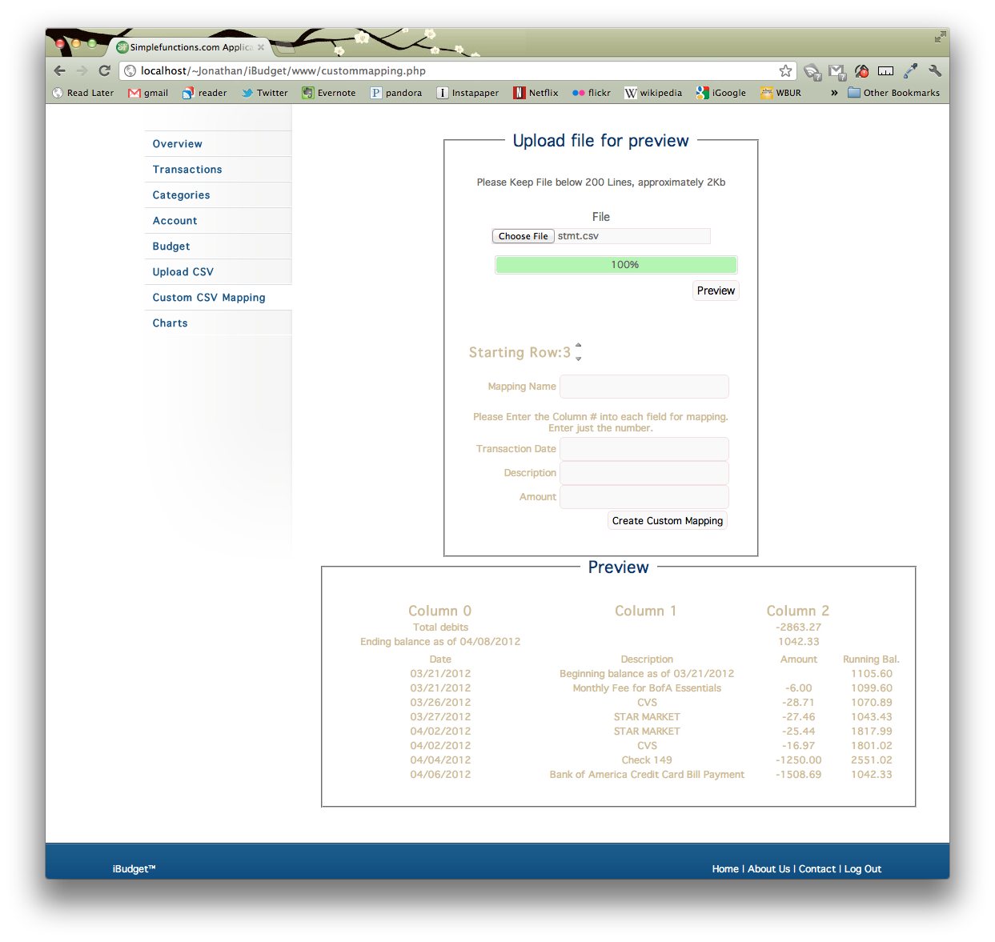

Once you’ve determined the starting row, fill in a name for your mapping, and fill in the column numbers for the 3 columns needed. In the case below, column 0 contains the Dates, column 1 has the description, and column 2 contains the transaction Amount.

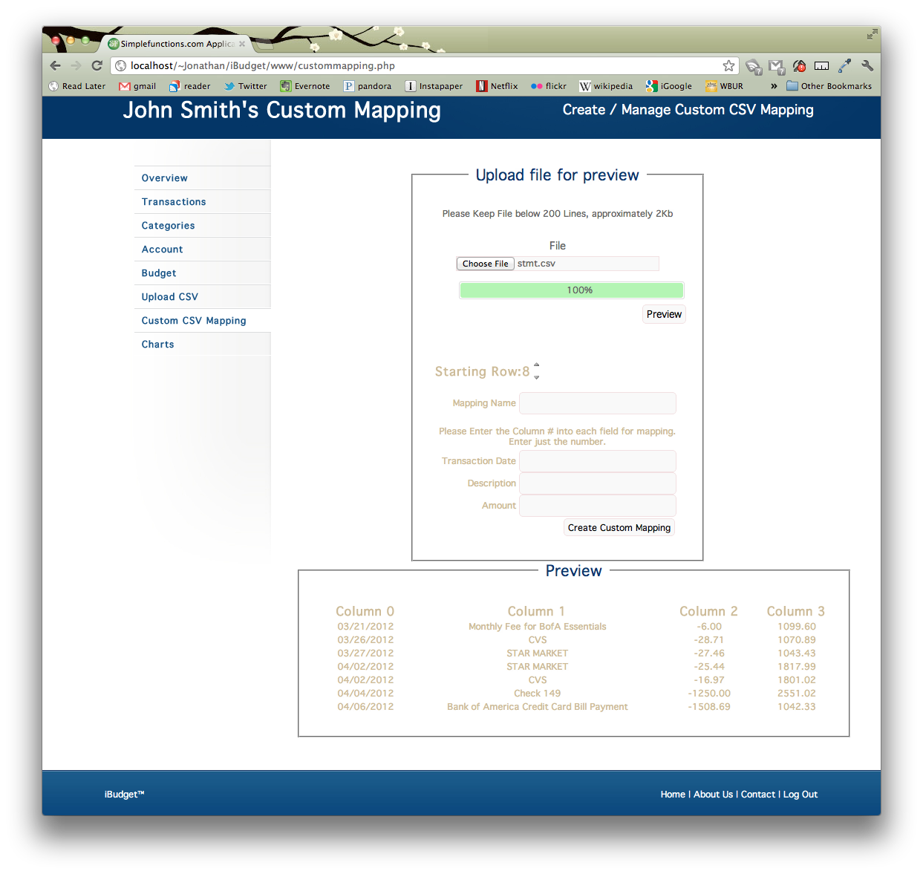

Once you’ve filled this information in, click “Create Custom Mapping” and you’re all set.

**Transactions**

Once you’ve uploaded at least one CSV file, you can view, edit, or delete any of your transactions. Click on the **Transactions** link in the *Dashboard Navigation Pane*.

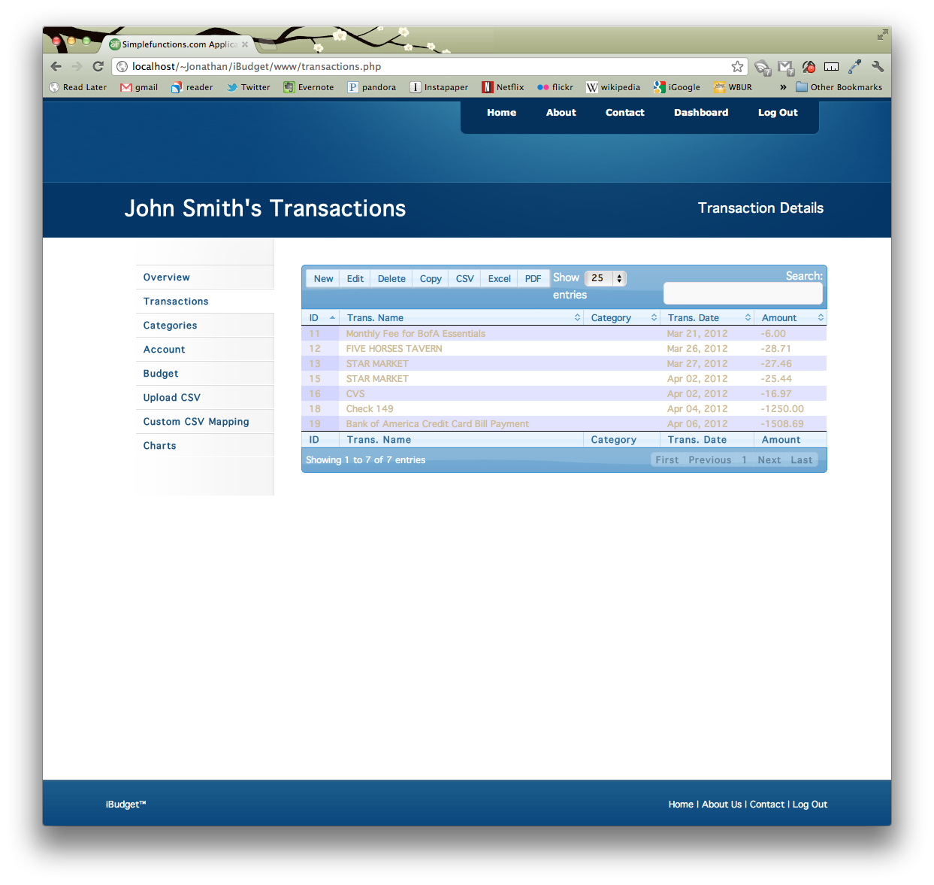

You can sort and search the transactions. You can also create new transactions or edit/delete a selected transaction. You can also export your transactions by using the “Copy”, “CSV”, “Excel”, or “PDF” buttons.

You can add a category (see Category section of this document) to a transaction by selecting the transaction and clicking the “Edit” button.

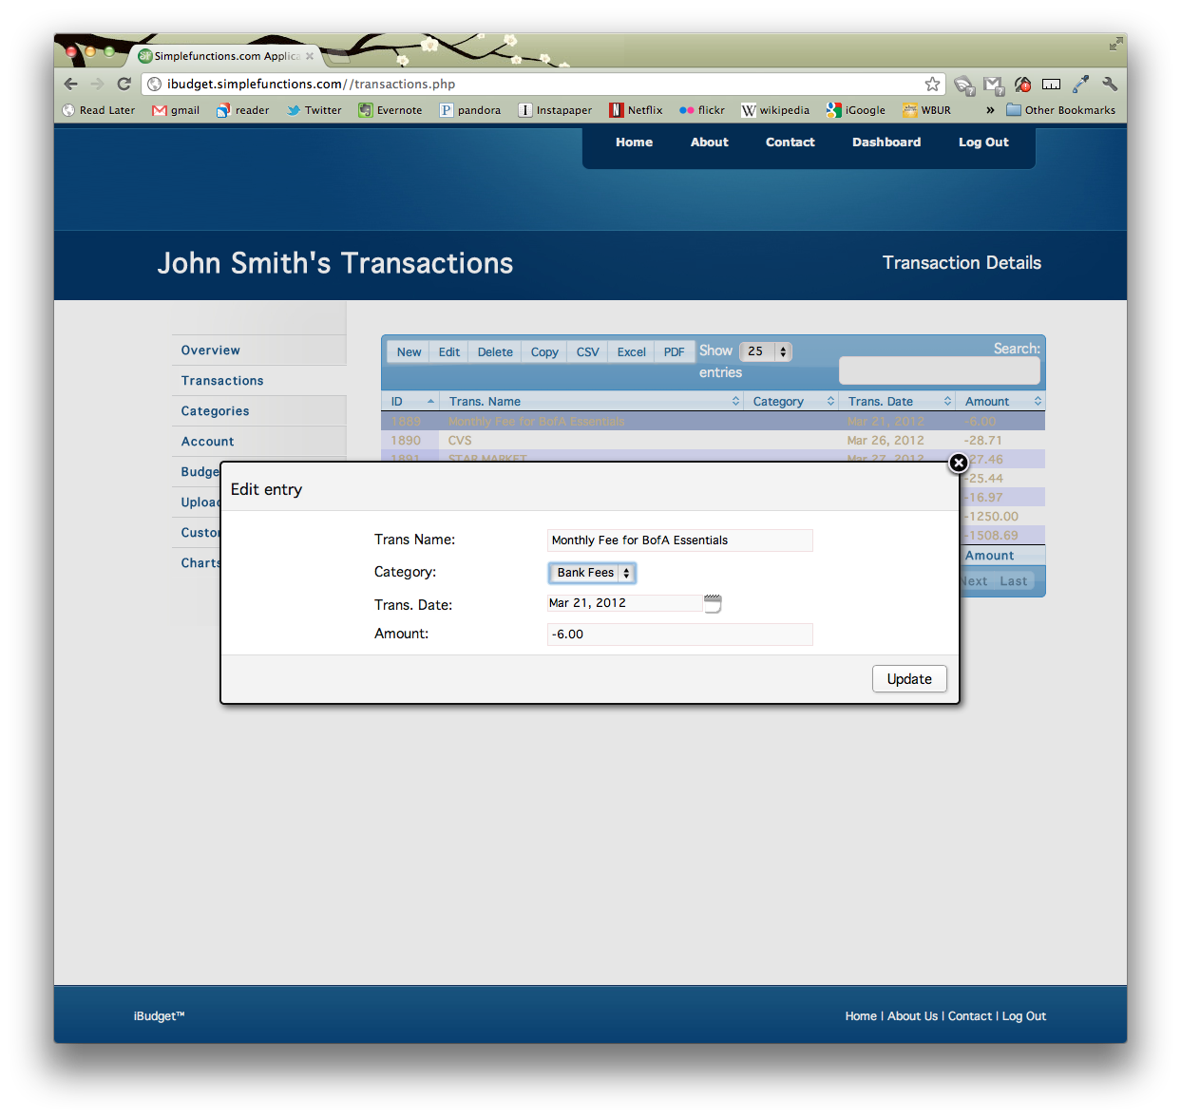

Select a category and then click the “Update” button.

**Budgets**

Budgets can be used to track your monthly spending on any Category you’ve created. When you create a budget, you select a category and a monthly allowance, you can then view all the budgets you’ve created and see how much you’ve spent in the current month on each budget, versus the amount you’ve allotted.

To manage budgets, click on the **Budget** link in the *Dashboard Navigation Pane*.

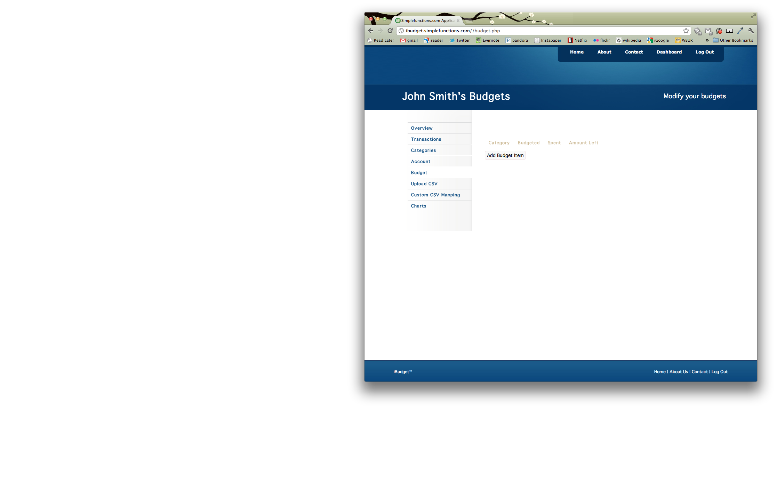

To add a budget item, click the “Add Budget Item” button. Then select a category, enter an allowance amount, and then click the “Save” button.

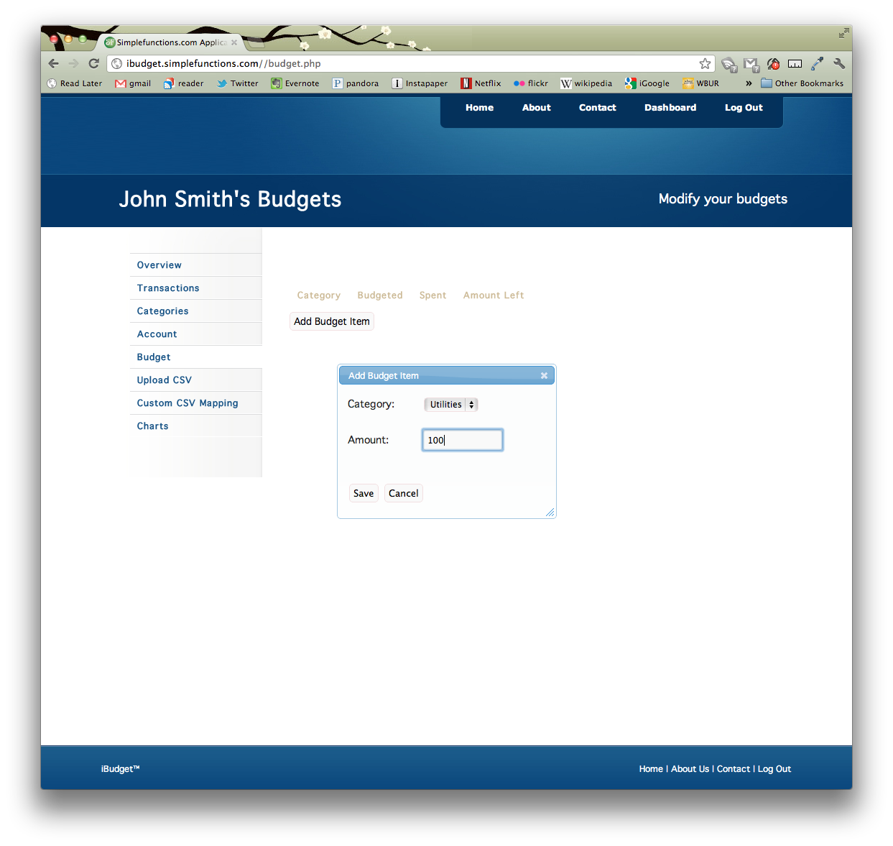

To delete a budget item, click the “Remove” button next to the budget item to delete.

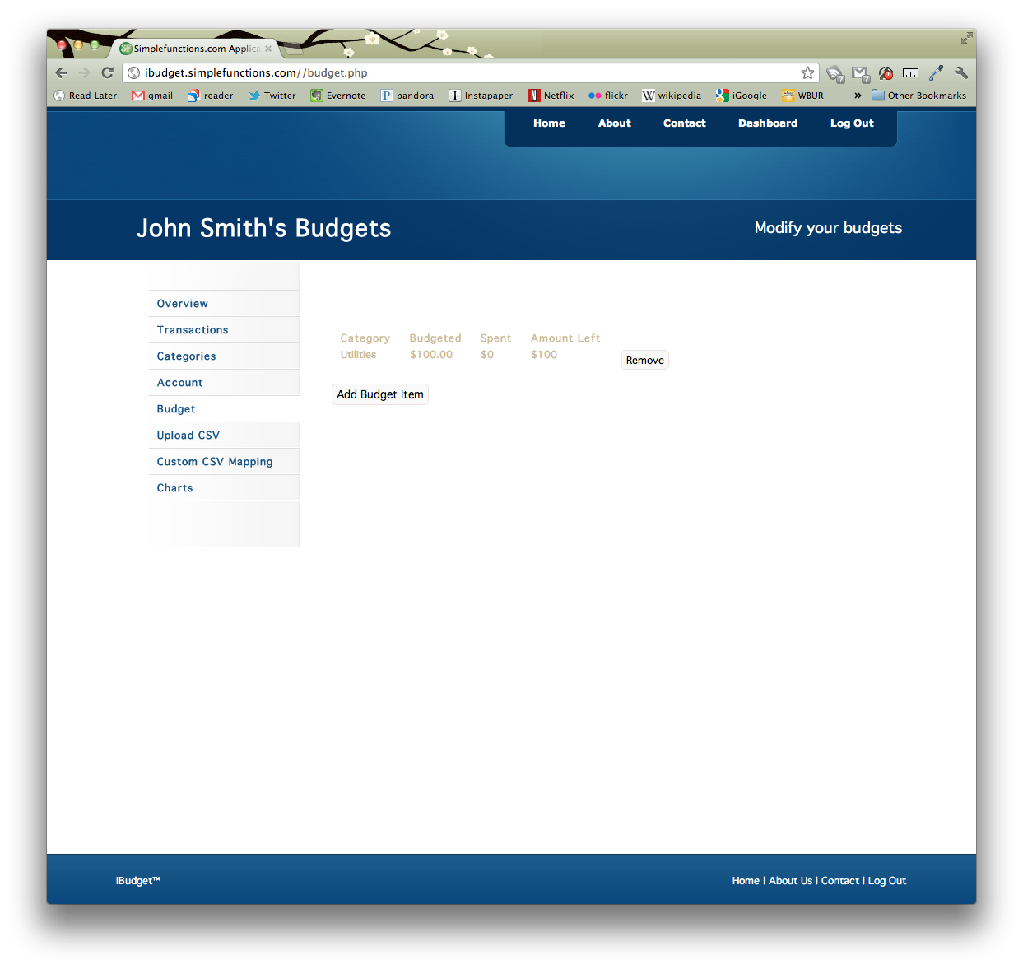

**Charts**

We’ve provided some helpful charts to visualize your transactions. To view these charts, click on the **Charts** link in the *Dashboard Navigation Pane*.

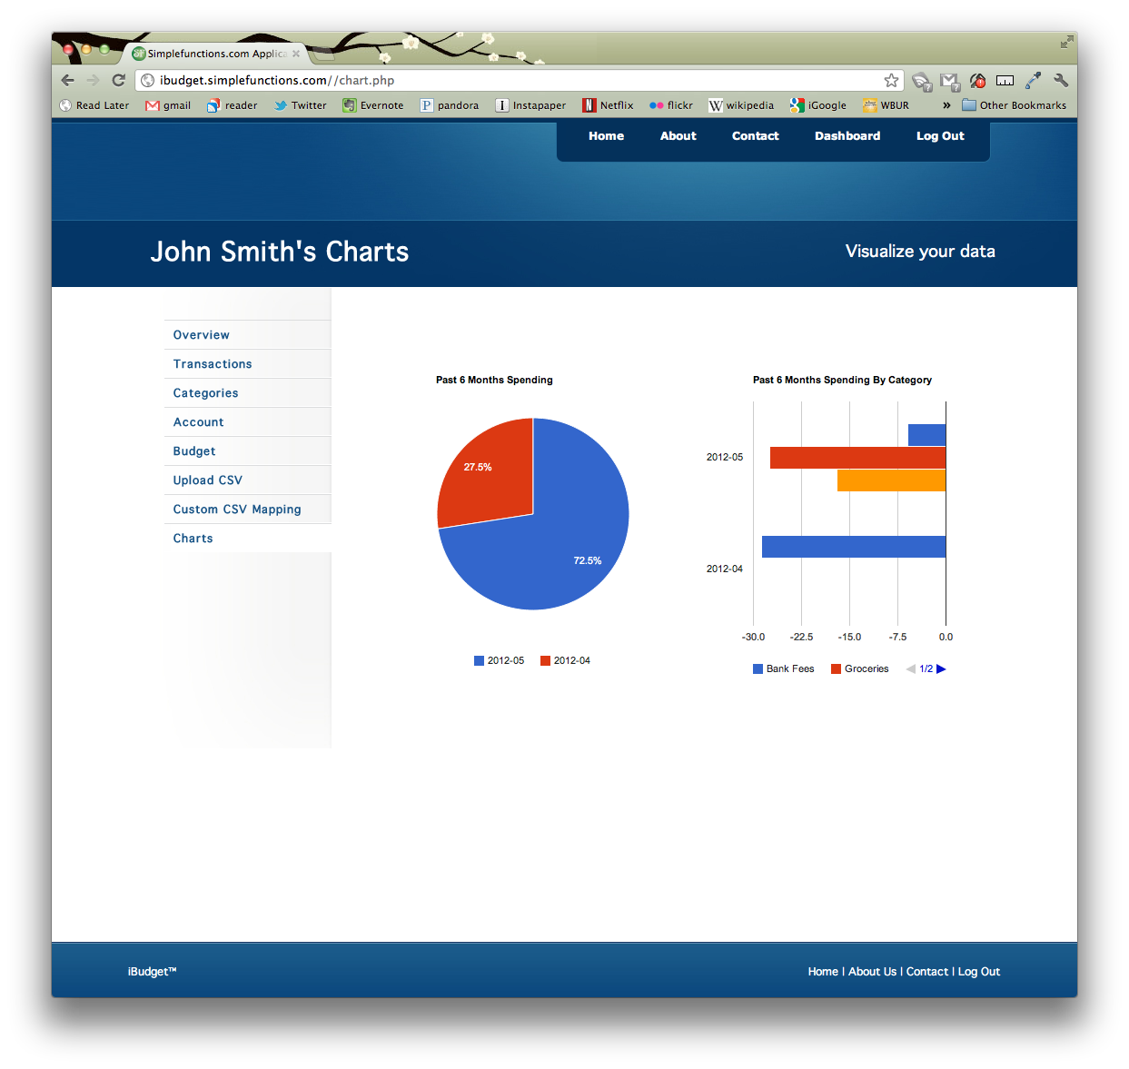

**Manage your Account**

If you need to reset your password or change the name associated with your account you can do this in the Account section. To manage your account, click on the **Account** link in the *Dashboard Navigation Pane*.

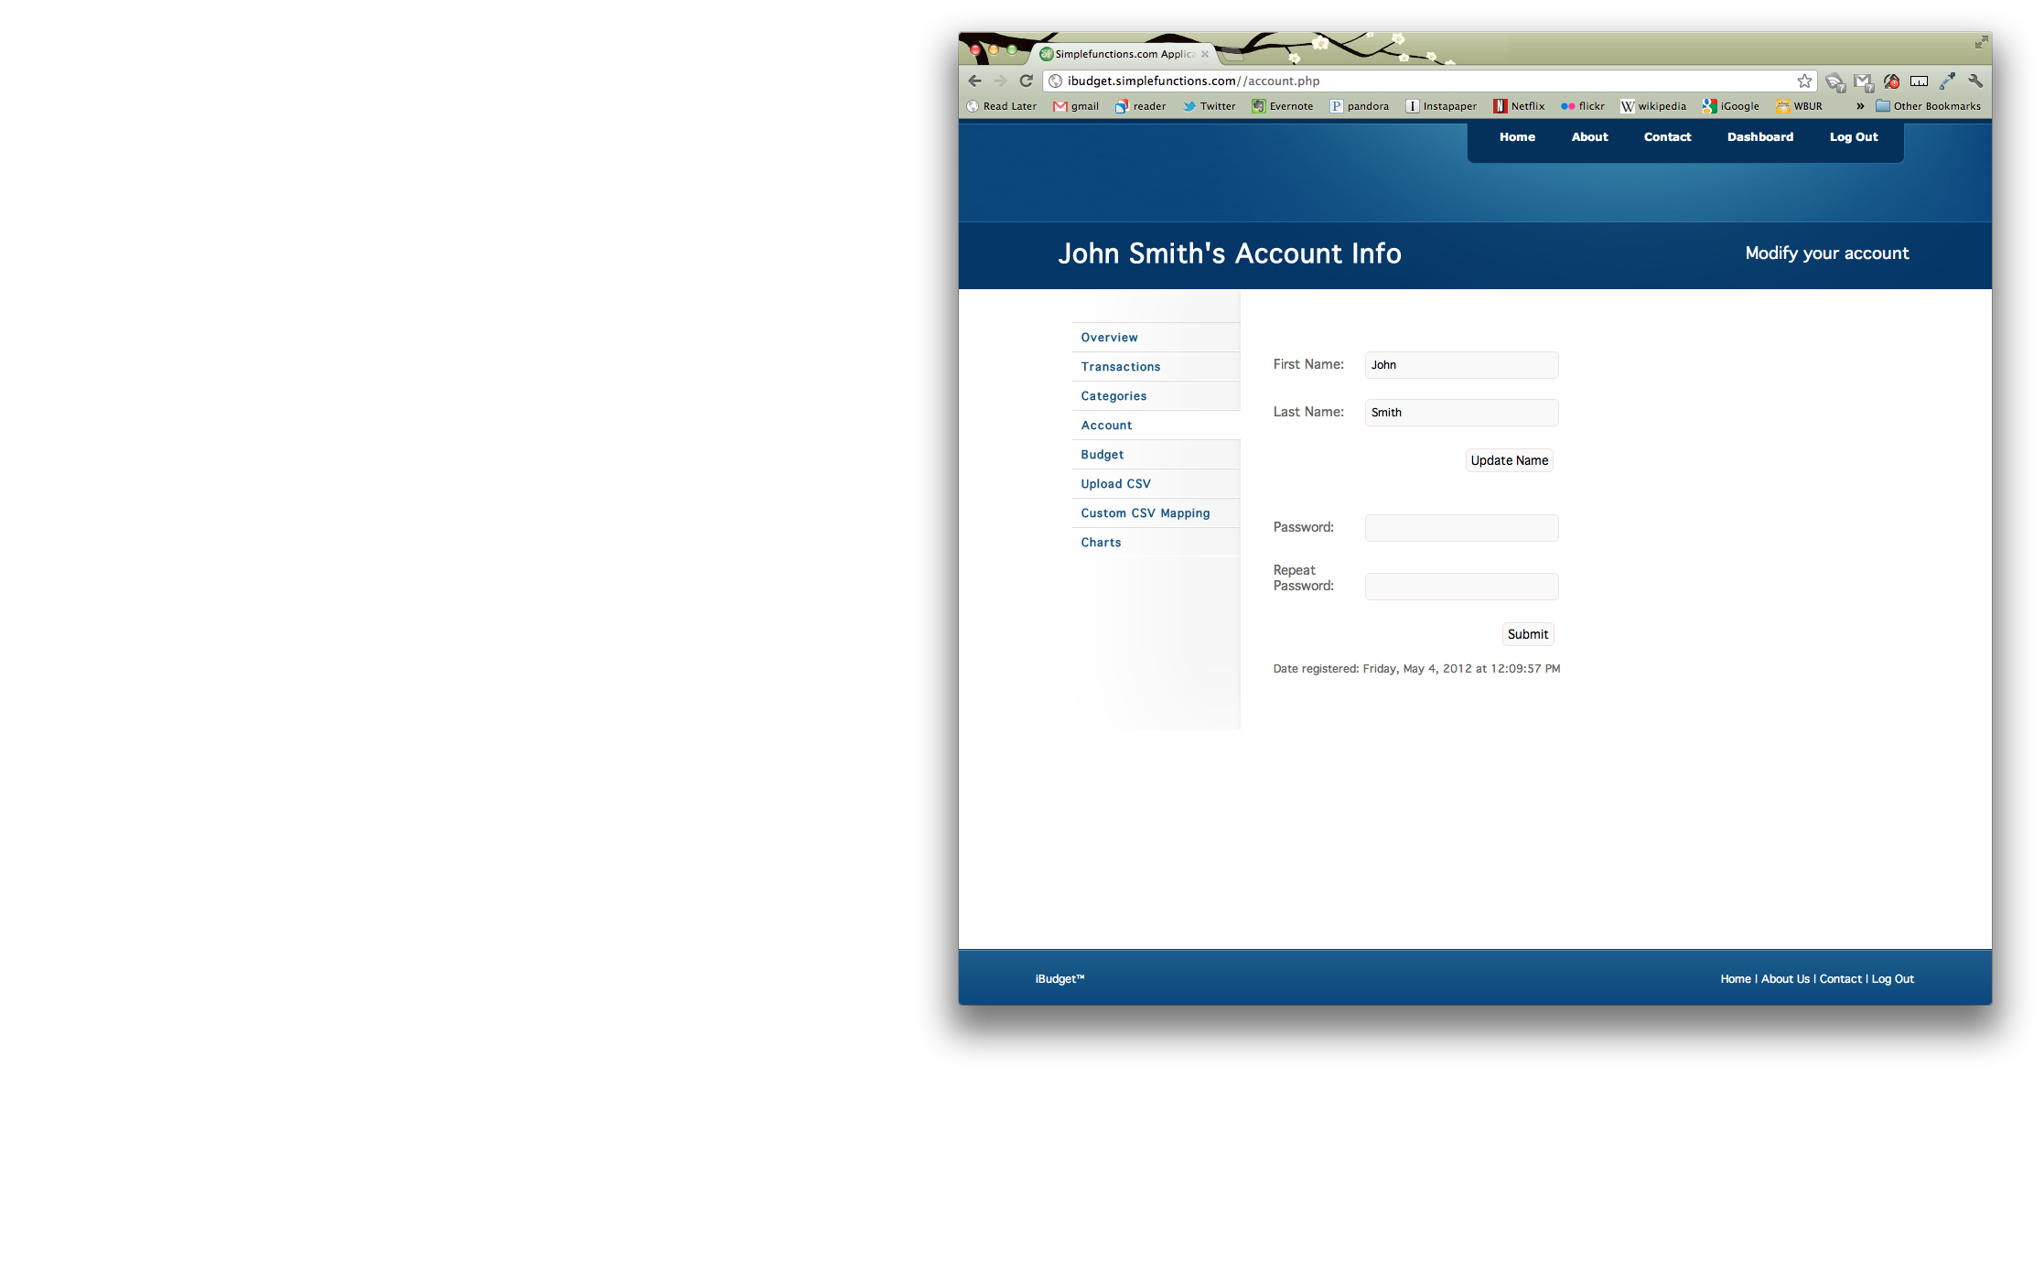

Fill in the information you’d like to change and then click on the appropriate button.

**Contact Us**

If you’d like to send us any feedback you can do this on the Contact page. To get to the contact page, click on the **Contact** link in the *Navigation Bar*.

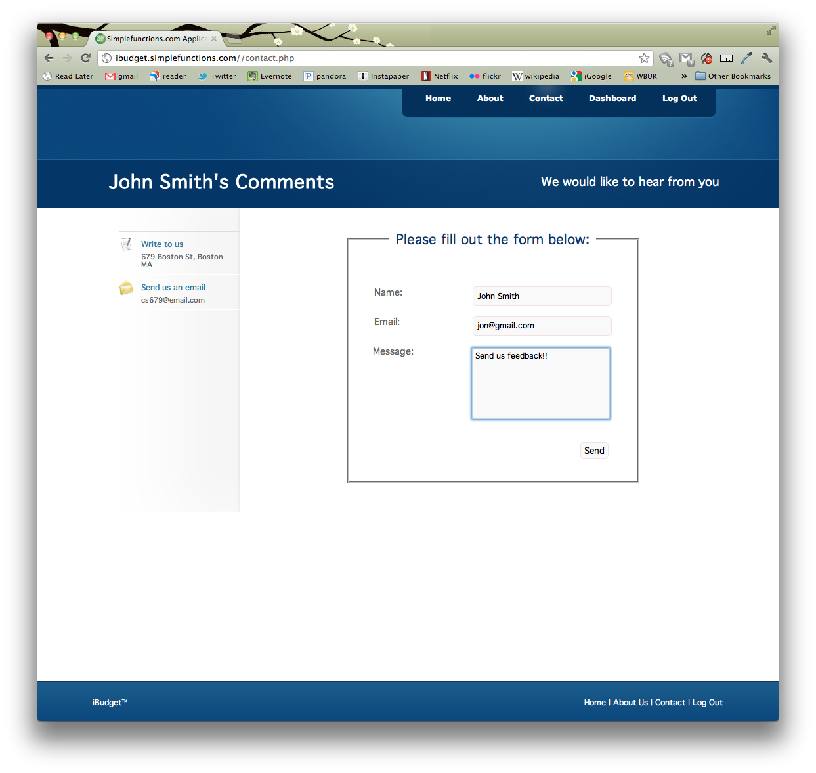

Fill in your name, email, and message, and then click the “Send” button. You can send feedback even if you aren’t logged in.

**Forgot your Password?**

If you forget your password, don’t worry, you can reset it through the email address you used as your account name.

From the Log In screen (**Log In** link on the *Navigation Bar*) click the “Forgot your password?” link.

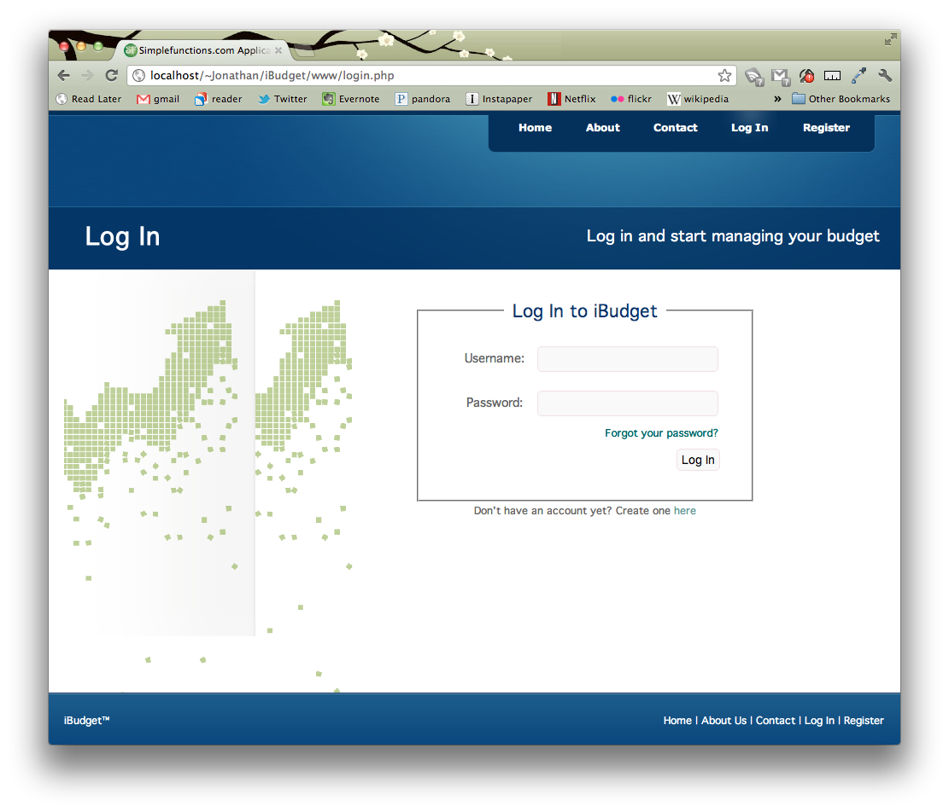

Enter the email address you use to log in and click the “Submit” button.

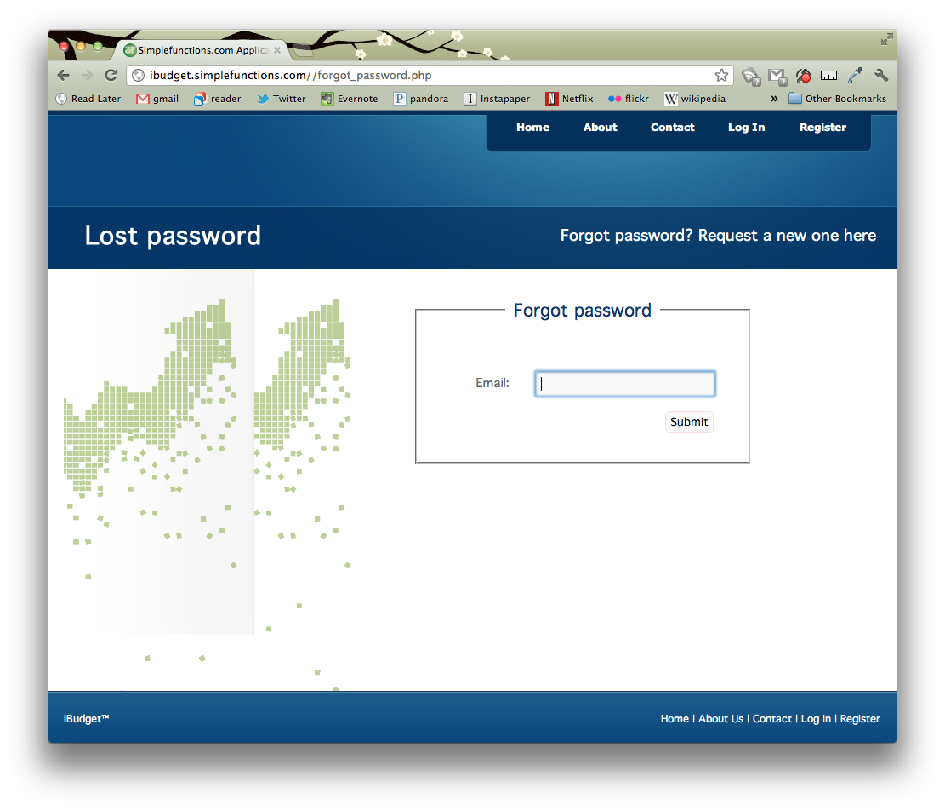

You should receive an email shortly, like the one below:

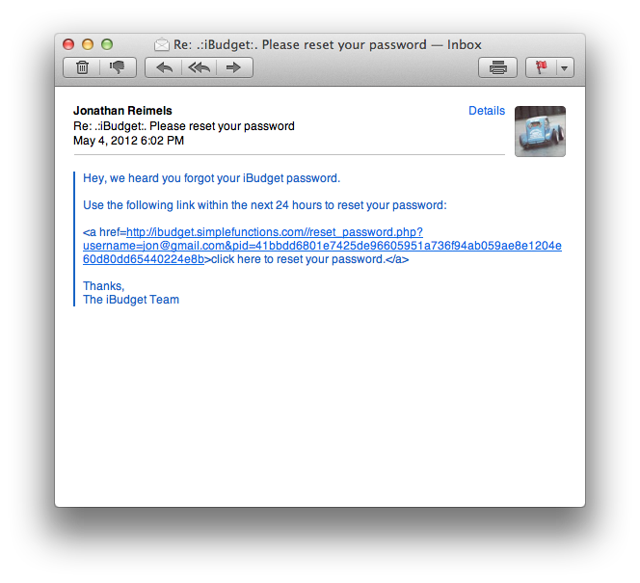

Click on the link, and you’ll find yourself at the Reset Password page. Enter a new password (remember passwords have to be at least 8 characters, must contain an upper case, lower case, numeric, and special character) and then click the “Submit” button.

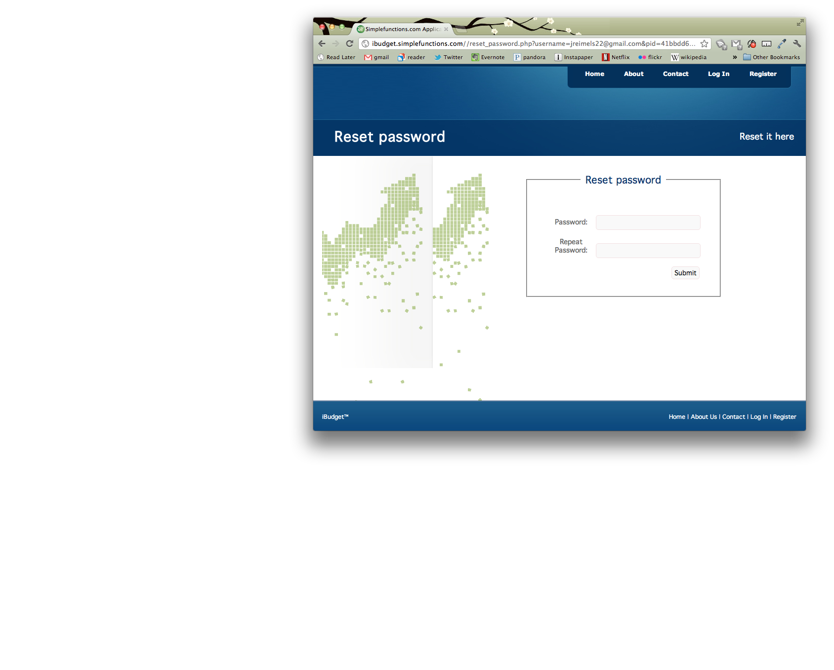

Your password is now reset, and you can use this new password to continue to access your account.